**OPERATING SYSTEM**

**LAB ASSIGNMENT – II**

**[4ITRC2]**

Name: Raghav Maheshwari

Roll No: 23I4057

Branch: IT - ‘A’

**Assignment 2: Study of Ubuntu Commands**

**Aim**: To study and understand Ubuntu Commands

**To perform**: Execute different Commands

**To Submit**: **Part1** Outputs of the following commands

* PWD

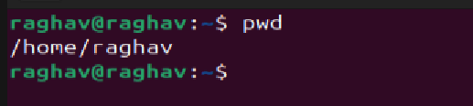

* CD

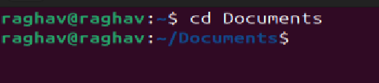

* LS

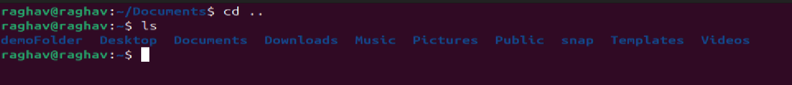

* MKDIR

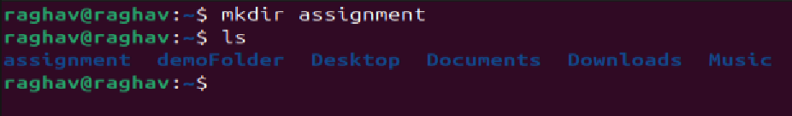

* RM

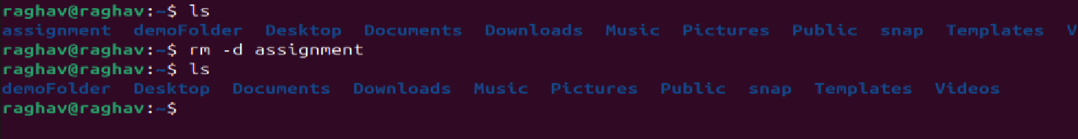

* TOUCH

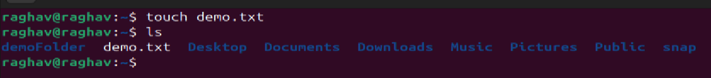

* HOSTNAME

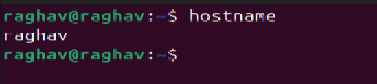

* CAT

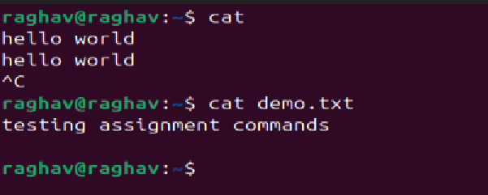

* CHMOD

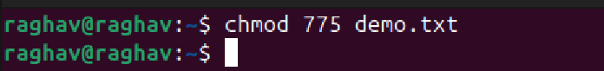

* ECHO

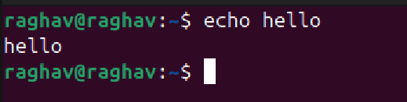

* GREP

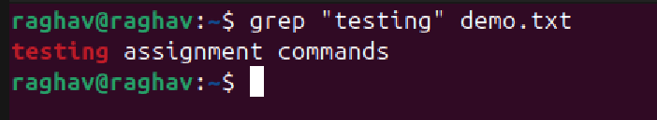

* FGREP

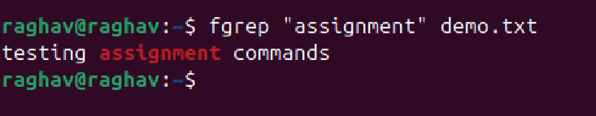

* MV

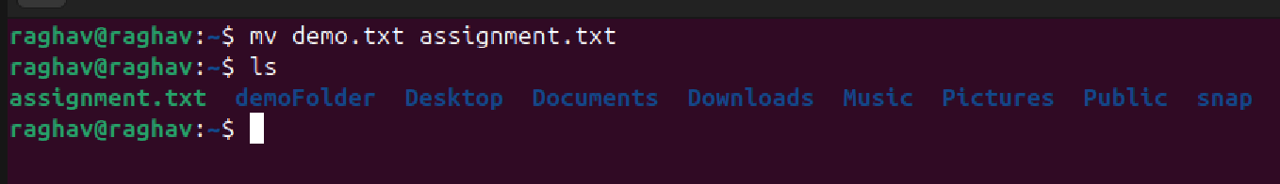

* CP

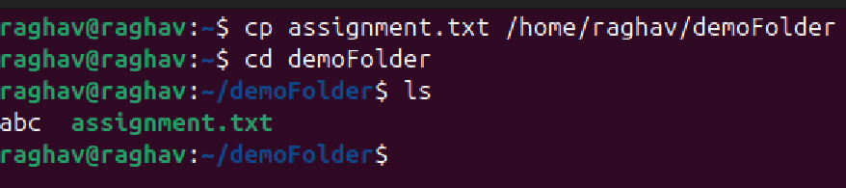

* MORE

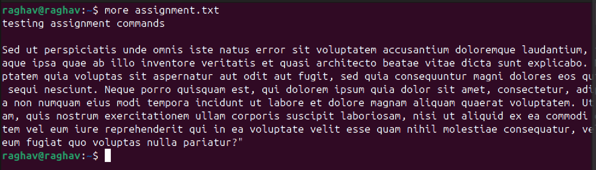

* LESS

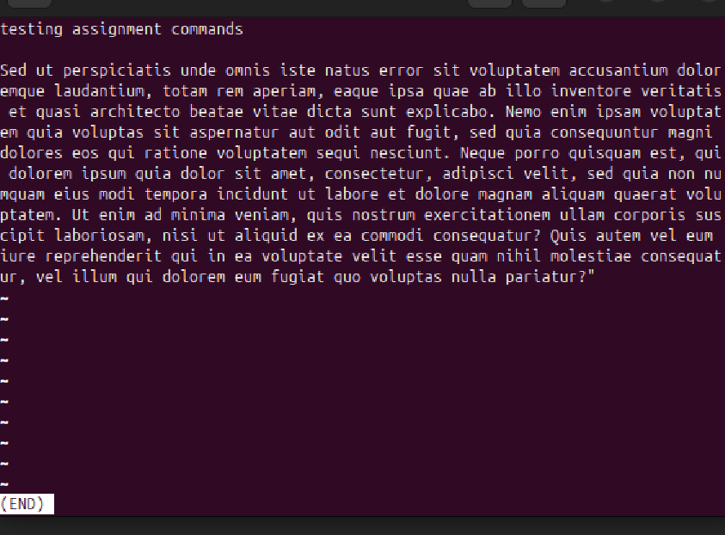

* WC

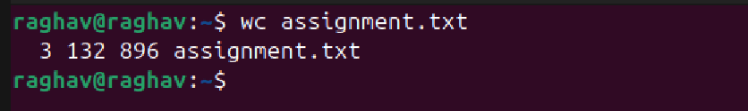

* AWK

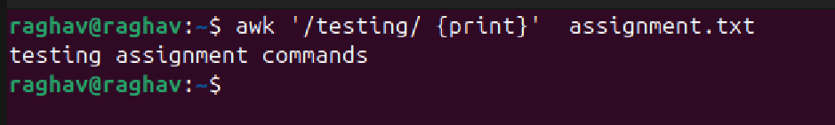

* SED

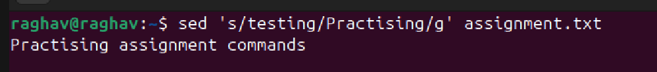

* TAIL

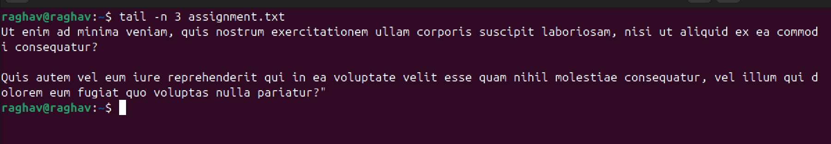

**Part 2** Answers to the following Questions:

1. **How to navigate to a specific directory?**  
   To move to a specific directory, use the cd command followed by the directory path:

cd /path/to/directory

1. **How to see detailed information about files and directories using ls?**  
   The ls -l command displays detailed information such as file permissions, owner, size, and modification date:

ls -l

1. **How to create multiple directories in Linux using mkdir?**  
   The mkdir command can create multiple directories by specifying their names:

mkdir dir1 dir2 dir3

1. **How to remove multiple files at once with rm?**  
   The rm command allows deleting multiple files by listing their names:

rm file1 file2 file3

1. **Can rm be used to delete directories?**  
   Yes, the rm -r command is used to delete directories along with their contents:

rm -r directory_name

1. **How do you copy files and directories in Linux?**  
   To copy a file:

cp source_file destination_directory

To copy a directory:

cp -r source_directory destination_directory

1. **How to rename a file using mv?**  
   The mv command is used to rename a file:

mv old_filename new_filename

1. **How to move multiple files using mv?**  
   The mv command allows moving multiple files to a destination directory:

mv file1 file2 file3 destination_directory/

1. **How to create multiple empty files using touch?**  
   The touch command creates multiple empty files at once:

touch file1 file2 file3

1. **How to view the content of multiple files?**  
   The cat command can be used to display the contents of multiple files:

cat file1 file2

1. **How to create a file and add content using cat?**  
   The cat command allows creating a file and entering content:

cat > filename

*(After typing, press Ctrl+D to save.)*

1. **How to append the contents of one file to another file using cat?**

cat file1 >> file2

*(Appends file1 content to file2.)*

1. **How to view a large file that doesn’t fit in the terminal?**

cat filename | less

*(Allows scrolling through long files.)*

1. **How to merge multiple files using cat?**

cat file1 file2 > merged_file

*(Combines file1 and file2 into merged_file.)*

1. **How to append text to an existing file using cat?**

cat >> filename

*(Type the content and press Ctrl+D to save.)*

1. **Explain chmod 777, chmod 755, and chmod +x.**

* chmod 777 filename → Full permissions for everyone.
* chmod 755 filename → Full permissions for the owner, read & execute for others.
* chmod +x filename → Makes the file executable.

1. **How to count the number of lines matching a string?**

grep -c "pattern" filename

*(Counts occurrences of a pattern in a file.)*

1. **How to display files that contain a specific string?**

grep -l "pattern" *

*(Lists filenames containing the pattern.)*

1. **How to show line numbers of matching lines in a file?**

grep -n "pattern" filename

*(Displays matching lines with line numbers.)*

1. **How to match lines starting with a specific string using grep?**

grep "^pattern" filename

1. **Can the sort command sort files in descending order by default?**  
   No, but it can be done using:

sort -r filename

1. **How to sort a file based on a specific column using sort?**

sort -k column_number filename